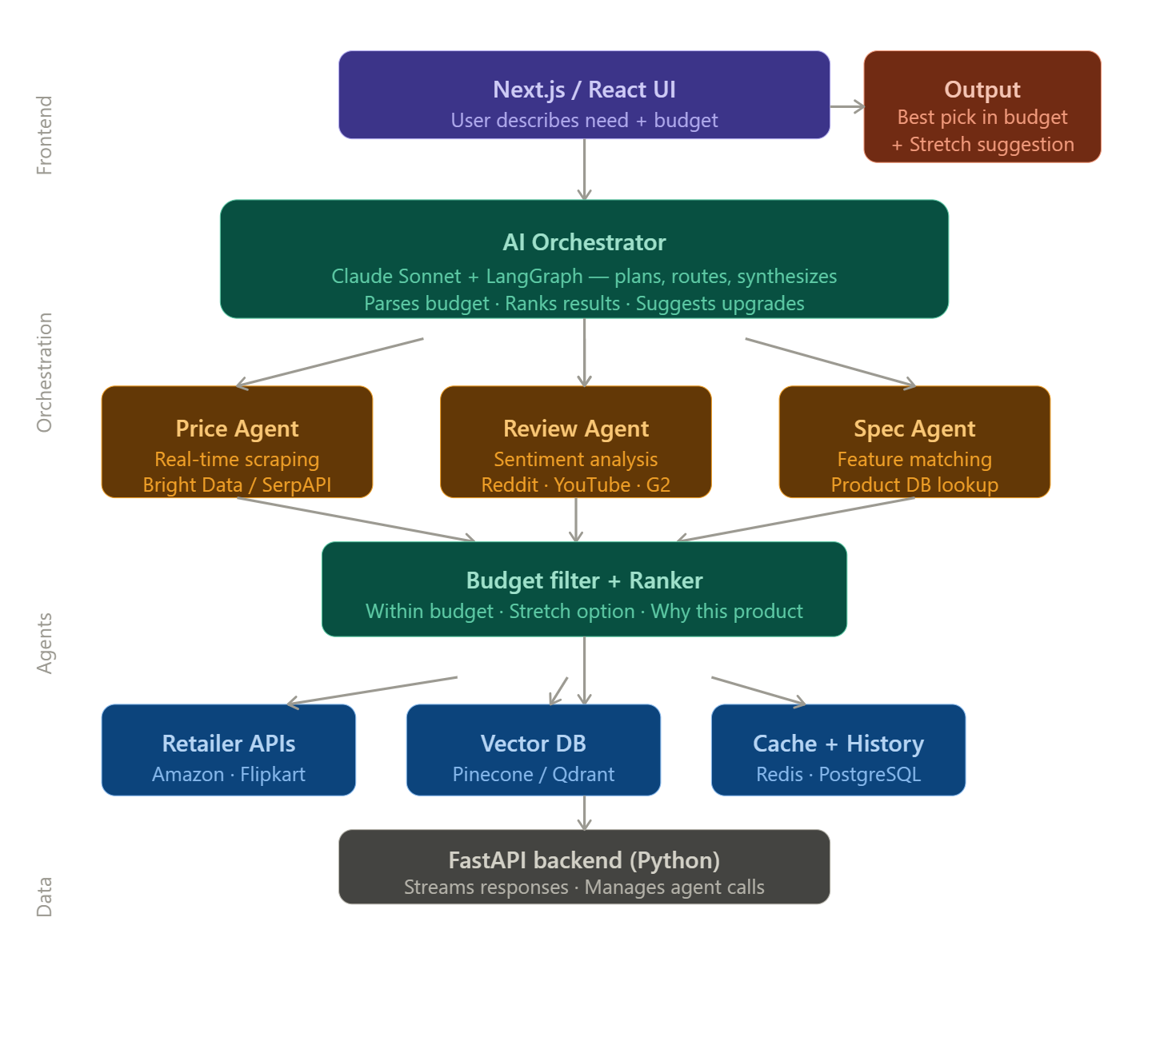
Core stack recommendation
For the AI brain, use Claude Sonnet (via Anthropic API) as your LLM, orchestrated with LangGraph (not plain LangChain — LangGraph gives you proper agent state machines which you need for multi-step reasoning like "fetch prices → filter by budget → rank → explain"). You don't need to build your own agentic framework from scratch.
Backend — Python + FastAPI is the natural fit here since LangGraph, LangChain tools, and most scraping/API libraries are Python-first. Stream responses to the frontend using Server-Sent Events so the user sees results as they arrive, not after a 10-second wait.
Real-time price comparison — this is the hard part. You have two options: use a paid API like SerpAPI (Google Shopping results) or Bright Data for structured product/price data, or scrape directly from Amazon/Flipkart using Playwright with rotating proxies. SerpAPI is easiest to start with. For Indian context, Flipkart has an affiliate API you can apply for.
Vector DB — embed product descriptions and user queries using OpenAI embeddings or sentence-transformers, store in Qdrant (free, self-hostable) or Pinecone. This lets you do semantic search ("I need something for video editing" → finds relevant product categories) rather than just keyword matching.
Frontend — Next.js + Tailwind. Build a chat-style interface where the user types their need and budget, and results stream in as cards with price, pros/cons, and a "why this?" explanation.
The budget stretch feature — this is simple prompt engineering. After ranking within-budget options, always run a second pass asking the LLM: "What would the user get if they spent 20% more?" and surface that as a clearly labeled "upgrade option."
What to build first (in order)
Start with a single agent that takes a query + budget, calls SerpAPI, filters by price, and returns the top 3 with a GPT/Claude explanation. Get that working end-to-end first. Then add the review sentiment agent (scrape Reddit/YouTube comments), then the vector search for semantic matching. Don't try to build all agents at once.
Smart thinking. Here's a lean, brick-by-brick workflow to get the core working first:
Phase 1 — Get one agent working (Day 1-2)
Start with just a Python script. No API, no frontend, nothing fancy.
user_query = "I need a laptop for video editing under ₹60,000"
- Call SerpAPI (Google Shopping) with the query
- Filter results by budget
- Pass the filtered results to Claude and ask it to pick the best one and explain why
- Print the output in terminal
Just get this loop working first. One file, maybe 50 lines.
Phase 2 — Add the stretch suggestion (Day 2)
Once Phase 1 works, add a second Claude call that says "what would they get if they spent 20% more?" Print both — the best within budget, and the upgrade option.
Phase 3 — Wrap it in FastAPI (Day 3)
Convert your script into a single POST endpoint:
POST /recommend
{ "query": "...", "budget": 60000 }
Test it with Postman or curl. No frontend needed yet.
Phase 4 — Add LangGraph (Day 4-5)
Refactor the logic into a proper LangGraph agent with nodes — one for price fetching, one for ranking, one for explanation. This is when it becomes truly agentic and you can add more data sources cleanly.
Phase 5 — Add review sentiment (Day 6-7)
Add a second agent that pulls Reddit/YouTube opinions on shortlisted products and factors that into the recommendation.
Phase 6 — Streaming + simple UI (Week 2)
Only now add a minimal frontend — even a plain HTML page with a form and a text box that streams the response is enough to demo.

The golden rule: each phase should be demoable before moving to the next. If Phase 1 isn't printing a clean recommendation in terminal, don't touch Phase 2.

